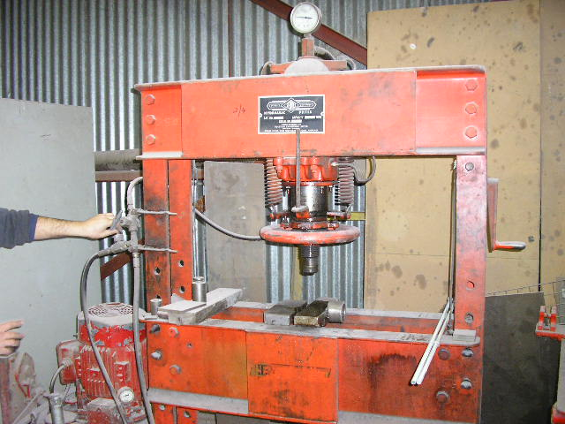 | Hazard Information Sheet
  Equipment: | Press
 | Equip Type: | Hydraulic Press
 | Generic Description or  Specific Make / Model: | Hydraulic Press
 | Type: | Electric
 | Other Details

Operator Requirements: | Operators must be trained and competent to use this equipment safely. Operators may be restricted by law and need special training.
Purpose For Which This Equip Is Designed: | For precision shaping of solid materials other than wood

Hazards & Risks:
Control Measures:
Entanglement (Guarding):  Limbs or clothing coming in contact with press arm | Operator to wear proper clothing goggles, steel toed safety boots, hearing protection (breathing mask or respirator, depending on work being done).
Fluid release:  Fluid released under pressure | Operator to ensure no nicks, cuts or damage to hoses before cable use.
Striking:  Movement of object being pressed and striking someone | PPE clothing to be worn at all times

Disclaimer: In fulfilment of its statutory obligations, (ARS) & John Holland has taken what it considers to be all reasonable precautions and exercised due diligence to ensure that it has provided all relevant information on the safe use of the plant. However, except as required by law and only to the extent so required, (ARS) & John Holland does not make any representation, warranty or undertaking, express or implied, as to, or accept any responsibility or liability for, the accuracy or completeness of, or any errors in or omissions from, this Hazard Information Sheet. Except as required by law and only to the extent so required, neither (ARS) & John Holland nor any of its respective directors, officers, agents, or employees shall in any way be liable directly or indirectly to any person or body for any loss or damages, costs or expenses whatever arising out of or in connection with the information contained in this Hazard Information Sheet. | Date: 19/06/06

